SEG Awards Level 2

Motor Vehicle Studies

**Underpinning Knowledge Evidence Record**

D/601/6171 Knowledge of Health, Safety and Good Housekeeping in the Automotive Environment

|  |  |
| --- | --- |
| **Learners Name** |  |
| **SEG Awards Registration Number** |  |
| **Centre Name** |  |
| **Assessor 1 Name** |  |
| **Assessor 2 Name** |  |

**DECLARATION OF AUTHENTICITY**

This declaration must be completed and signed by the learner and countersigned by the tutor / assessor and covers all evidence submitted for moderation.

|  |  |  |  |
| --- | --- | --- | --- |
| Learner Name |  | | |
| Unique Learner Number (ULN) |  | SEG  Learner Reg. ID |  |
| Qualification Title |  | | |
| Centre Name |  | | |

# Learner statement of authenticity

**Before signing please read the guidance below**.

I confirm, that the attached assignment / portfolio is all my own work[1] and does not include any work completed by anyone other than myself. I have completed the assignment / portfolio in accordance with SEG Awards’ instructions and within the time limits set by my centre.

|  |  |  |  |
| --- | --- | --- | --- |
| Signature |  | Date |  |

# Centre confirmation of authenticity

On behalf of …………………………………….(insert centre name), I confirm that the above mentioned learner, to the best of my knowledge, is the sole author of the completed assignment / portfolio attached, and the assessments have been completed under the required conditions.

|  |  |  |  |
| --- | --- | --- | --- |
| Signed |  | Date |  |
| Name |  | | |
| Title |  | | |

**Guidance for Learners**

You have been asked to sign this Declaration of Authenticity and place it at the front of your portfolio or course work assessment. It confirms that the work you have submitted for assessment is your own and that you have not copied it from someone else or allowed another learner to copy it from you.

When preparing any course work it is good practice to undertake research using information from published sources. If you quote directly from these sources then this must be indicated in your work by using quotation marks and referencing the document from which the quotation was taken. You must then comment in your own words on any ideas expressed.

Assessors, internal verifiers and SEG Awards’ external moderators and verifiers are subject specialists who can spot the use of published materials that may be passed as your own words or ideas.

If you do copy words from a published source and do not indicate their reference you will be committing plagiarism. This is considered a form of cheating and may result in your assessment being declared void.

**Contents**

|  |  |  |
| --- | --- | --- |
| **Task No** | **Title** | **Assessment Criteria** |
| 1 | Personal PPE | 1.1 |
| 2 | Vehicle protective equipment | 1.2 |
| 3 | Roadside assistance | 1.3 |
| 4 | Cleaning work environment | 2.1, 2.2, 2.4, 2.5, 2.7 |
| 5 | Minimising waste | 2.3, 2.6 |
| 6 | Health and safety legislation | 3.1, 3.2 |
| 7 | Hazardous substances | 4.6 |
| 8 | Hazard and risk | 4.3, 4.3 |
| 9 | Fire extinguishers | 4.4 |
| 10 | Warning signs | 4.5 |
| 11 | Workplace policies | 3.4, 4.2 |

|  |  |
| --- | --- |
| **Task 1 – Personal PPE** | **Assessment Criteria 1.1** |

**Personal protective equipment (PPE) is defined as ‘all equipment (including clothing affording protection against the weather) which is intended to be worn or**

**held by a person at work and which protects them against one or more risks to**

**their health or safety’,**

**Below are examples of PPE worn or used in the motor vehicle environment.**

|  |  |  |
| --- | --- | --- |
| **Complete the table by naming the PPE indicated and stating what it will protect the wearer/user from** | | |
| **PPE** | **Name** | **Why worn/used** |
|  |  |  |
|  |  |  |
|  |  |  |
|  |  |  |
|  |  |  |
|  |  |  |
|  |  |  |
|  |  |  |

|  |  |
| --- | --- |
| **Task 2 – Vehicle protective equipment** | **Assessment Criteria 1.2** |

**Whilst working on a vehicle in a motor vehicle workshop it is important to protect that vehicle from damage or contamination by using vehicle protective equipment (VPE)**

|  |  |
| --- | --- |
| **Complete the table below by identifying the protection offered by the VPE listed** | |
| **VPE** | **Protects vehicle from** |
| **Wing covers** |  |
| **Seat covers** |  |
| **Steering wheel cover** |  |
| **Disposable floor mats** |  |

|  |  |
| --- | --- |
| **Task 3 – Roadside assistance** | **Assessment Criteria 1.3** |

**Attending a vehicle at the roadside can be very dangerous, it is recommended that a motor vehicle technician that is expected to work in this situation be specially trained.**

**Below are points that need to be considered when working at the roadside.**

|  |  |
| --- | --- |
| **Complete the table by giving a reason for the points raised** | |
| **Safety points** | **Reason** |
| **Type of road**  **(motorway, dual carriageway, narrow road)** |  |
| **Vehicle position**  **(on the carriageway, hard shoulder, lay-by)** |  |
| **Road visibility**  **(day, night, well lit, not lit)** |  |
| **Weather conditions**  **(wet, dry fog )** |  |
| **Breakdown vehicle position**  **(recommended as in-line with traffic flow behind the stranded vehicle)** |  |
| **Spillage of fuel or oil** |  |
| **Stranded vehicle occupants position** |  |

|  |
| --- |
| **Wearing the correct personal PPE is also important in this situation.**  **List THREE items of PPE that would be used when attending a vehicle at the roadside** |
| **1:** |
| **2:** |
| **3:** |

|  |  |
| --- | --- |
| **Task 4 – Cleaning work environment** | **Assessment Criteria 2.1, 2.2, 2.4, 2.5, 2.7** |

|  |
| --- |
| **Keeping the workshop environment clean and tidy is very important.**  **List 3 reasons why the workshop should be kept clean** |
| **1:** |
| **2:** |
| **3:** |

|  |  |  |
| --- | --- | --- |
| **Particular housekeeping tasks are performed at the start and end of the day. Complete the table below outlining 3 tasks that are carried out in your workplace or training workshop** | | |
| **Task** | **Start of the Day** | **End of the day** |
| **1:** |  |  |
| **2:** |  |  |
| **3:** |  |  |

|  |  |
| --- | --- |
| **Tools and equipment should be cleaned and maintained to ensure they operate correctly.**  **Complete the table below by describing the checks and cleaning method for the groups of tools and equipment shown.** | |
| **Tools** | **Cleaning and maintenance** |
| **Hand tools** |  |
| **Air tools** |  |
| **Jacks and vehicle lifts** |  |
| **Electrical tools** |  |
| **Electrical equipment** |  |

|  |
| --- |
| **In all motor vehicle workshops, spillages of liquids will occur from time to time**  **List below the procedure for dealing with spillages in your workshop** |
| **1:** |
| **2:** |
| **3:** |

|  |  |
| --- | --- |
| **Task 5 – Minimising waste** | **Assessment Criteria 2.3, 2.6** |

**Minimising waste can help the company reduce costs and improve profitability**

**Waste can mean the utilities and consumables used as well as the disposal of used parts.**

|  |  |
| --- | --- |
| **Explain how the following can be best utilised to reduce costs** | |
| **1. Workshop heating** |  |
| **2. Workshop lighting and power usage** |  |
| **3. Consumables**  **(nuts, bolts washers etc)** |  |

**During normal maintenance and repair of motor vehicles waste products are produced**

|  |  |
| --- | --- |
| **Explain how the following could be disposed of whilst reducing the impact on the environment** | |
| **1. Metals** |  |
| **2. Cardboard and paper packaging** |  |
| **3. Waste oils** |  |
| **4. Plastics** |  |

|  |  |
| --- | --- |
| **Task 6 – Health and safety legislation** | **Assessment Criteria 3.1, 3.2** |

**The basis of British health and safety law is the *Health and Safety at***

***Work etc***

***Act 1974.***

**The Act sets out the general duties which employers have towards employees and members of the public, and employees have to themselves and to each other.**

|  |  |  |
| --- | --- | --- |
| **Refer to the act and outline THREE duties of the employer and employee in the table below** | | |
| **Duty** | **Employer** | **Employee** |
| **1:** |  |  |
| **2:** |  |  |
| **3:** |  |  |

|  |  |
| --- | --- |
| **Task 7 – Hazardous substances** | **Assessment Criteria 4.6** |

**Motor vehicle repair often involves working with** [**substances that are hazardous to health**](http://www.hse.gov.uk/coshh/detail/substances.htm)**[1].**

**The Control of Substances Hazardous to Health (COSHH) Regulations 2002 is the law that requires employers and employees to ensure that hazardous substances used in a workplace do not affect adversely the workforce or others.**

**Substances that are hazardous usually have a warning symbol on the packaging. Some common symbols are shown below**

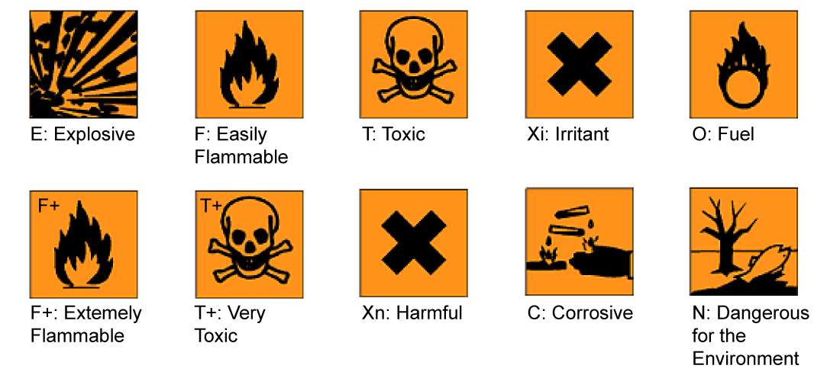

|  |
| --- |
| **Investigate the products used in your workshop and identify THREE substances that would come under COSHH regulations** |
| **1:** |
| **2:** |
| **3:** |

|  |  |
| --- | --- |
| **Task 8 – Hazard and risk** | **Assessment Criteria 4.3, 4.3** |

**Definitions**

**HAZARD Anything that has the potential to cause harm**

**RISK The chance or probability that a hazard WILL cause harm**

**Look at the motor vehicle workshop layout shown below and circle 6 HAZARDS that you see.**

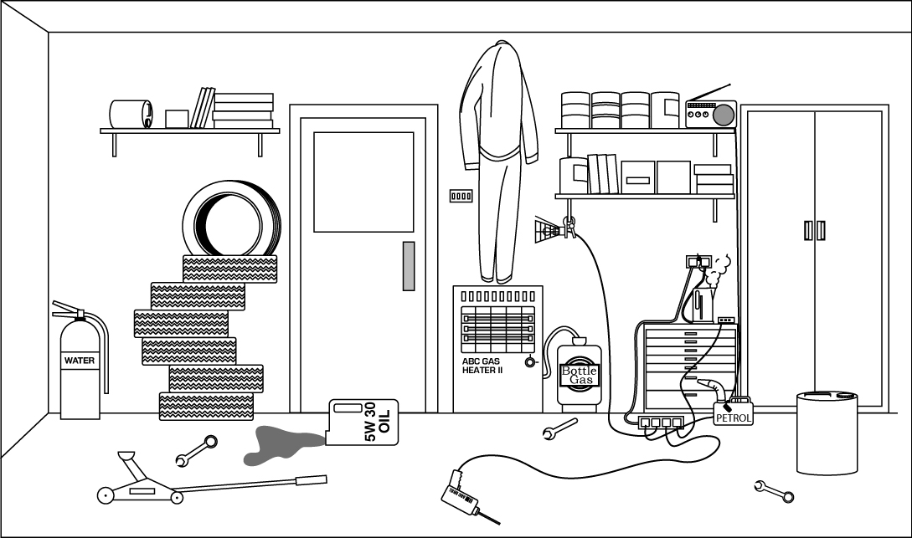

**Having identified the hazards, the risks must be considered**

|  |  |  |  |
| --- | --- | --- | --- |
| **Choose THREE hazards and complete the table below by outlining what risk they pose and what could be done to reduce this risk** | | | |
| **Number** | **Hazard** | **Risk** | **Risk reduction** |
| **1** |  |  |  |
| **2** |  |  |  |
| **3** |  |  |  |

|  |  |
| --- | --- |
| **Task 9 – Fire extinguishers** | **Assessment Criteria 4.4** |

|  |  |  |  |  |
| --- | --- | --- | --- | --- |
| **All motor vehicle workshops will have fire extinguishers placed in them, but not all extinguishers are suitable for some types of fire.**  **Investigate the fire extinguishers in your workshop and complete the diagram below by indicating the type of extinguisher suitable for each type of fire.**  **The first one has been completed to help you** | | | | |
| **TYPE OF FIRE** |  |  |  |  |
| Type A  Paper, Wood, Textile and Fabric | ✔ |  |  |  |
| Type B  Flammable Liquids |  |  |  |  |
| Type C  Flammable gases |  |  |  |  |
| Type E  Electrical Equipment |  |  |  |  |

|  |  |
| --- | --- |
| **Task 10 – Warning signs** | **Assessment Criteria 4.5** |

Safety signs and colour are useful tools to help protect the health and safety of employees and workplace visitors. The shape and colour of signs determines the type of warning given

Below are 4 types of safety sign and their description.

Investigate warning signs in your workshop and insert TWO examples of each type in the space provided.

|  |  |  |
| --- | --- | --- |
| **Prohibition (Must NOT)** | **Example 1** | **Example 2** |
| Round shape, red edging and diagonal line, black pictogram on white background |  |  |
| **Mandatory (Must DO)** | **Example 1** | **Example 2** |
| Round shape, white pictogram on blue background |  |  |
| **Hazard Alert (Warning)** | **Example 1** | **Example 2** |
| Triangular shape, black edging  pictogram on yellow background |  |  |
| **Safety Information (Safe situation)** | **Example 1** | **Example 2** |
| Rectangular or square shape  white pictogram on green background |  |  |

|  |  |
| --- | --- |
| **Task 11 – Workplace policies** | **Assessment Criteria 3.4, 4.2** |

|  |
| --- |
| **To ensure they comply with health and safety, companies have rules (known as policies and procedures) that employees are expected to follow**  **What are your company’s (or training company) rules with regard to:** |
| **Protective clothing you are expected to wear** |
|  |
| **Smoking in the workshop** |
|  |
| **Eating and drinking in the workshop** |
|  |
| **Moving Vehicles** |
|  |
| **Reporting accidents** |
|  |

1. Unless otherwise stated e.g. for some entry level qualifications, learners can work together but should identify sections which are their own work.